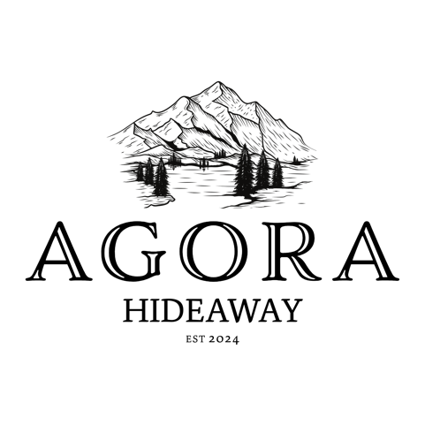

**Statement of Environmental**

**Effects for Agora Hideaway**

**Project Overview**

Agora Hideaway proposes to host recreational camping events on a quarterly basis. These events will accommodate up to 200 participants, including up to 100 caravans, on the property located at Mole River, NSW.

**Purpose of the Statement**

This Statement of Environmental Effects (SEE) outlines the environmental impacts of the proposed development and the measures that will be implemented to mitigate these impacts. It also addresses compliance with relevant planning policies and controls.

**Environmental Impacts of the Development**

**Site Disturbance**

**During Development:** Minimal site disturbance is anticipated, as the events will use existing cleared areas for camping. Any necessary ground preparation will be limited to temporary setups and will not involve significant earthworks.

**After Development:** The site will be restored to its natural state following each event, with no permanent structures or alterations.

**Waste Management**

Bins for domestic waste will be provided and regularly serviced during events. All waste will be disposed of responsibly by Agora Hideaway after each event, ensuring minimal impact on the environment.

**Noise Pollution**

Noise levels will be controlled to comply with local regulations, and events will be held at a distance from neighbouring properties to minimise disturbance with quiet time instated between 10pm and 7am and generators only being allowed to be run between 7am and 7pm daily.

**Traffic and Access**

Traffic and caravan site management will be implemented to ensure safe and controlled access with sufficient space between campers, cars and caravan sites. Volunteers and/or signage will be utilised to direct participants, reducing the likelihood of congestion or impact on local roads.

**Identification of Environmental Impacts**

**Methods Used**

Site inspection with council has been conducted to identify potential environmental impacts. Analysis of similar events in comparable settings held by sister company “Big Oz Explorers” has provided insights into possible impacts and effective mitigation strategies.

**Mitigation Measures**

**Site Management**

Temporary facilities, such as toilets and waste bins, will be carefully managed to minimise environmental impact. They will be positioned appropriately to avoid disturbance to waterways. After each event, the site will be thoroughly cleaned and inspected.

**Emergency Preparedness**

Evacuation plans and emergency procedures will be in place to address potential risks, such as fire or flood. RFS Mapping data will be utilised for precise location tracking and emergency response.

**Noise Control**

Sound levels will be monitored, and event programming will be designed to limit noise during sensitive hours.

**Waste Reduction**

Recycling initiatives will be promoted among participants, and all waste will be appropriately sorted and disposed of at the end of the event by Agora Hideaway.

**Compliance with Planning Policies and Controls**

**Zoning and Land Use**

The proposed development is consistent with the current zoning regulations and land use policies for Temporary Use of Land under Clause 2.8 of *Tenterfield Local Environmental Plan 2013*.

**Building Height and Setbacks**

As the development does not involve permanent structures, there are no implications for building height, setbacks, or building envelope controls.

**Landscape and Aesthetic Considerations**

The natural landscape will be preserved, and any temporary structures will be designed to blend with the surrounding environment. No permanent changes to the landscape are proposed.

**Contextual Considerations**

**Surrounding Development**

The site is located in a rural setting with minimal surrounding development. The proposed events are in harmony with the character of the area.

**Future Development Context**

There is no anticipated significant change in the surrounding built form. The proposed events will continue to align with the rural nature of the area.

**Supporting Visuals**

**Drawings and/or Plans**

Drawings of the site layout, including the placement of temporary facilities (orange) and camping areas, are included below.

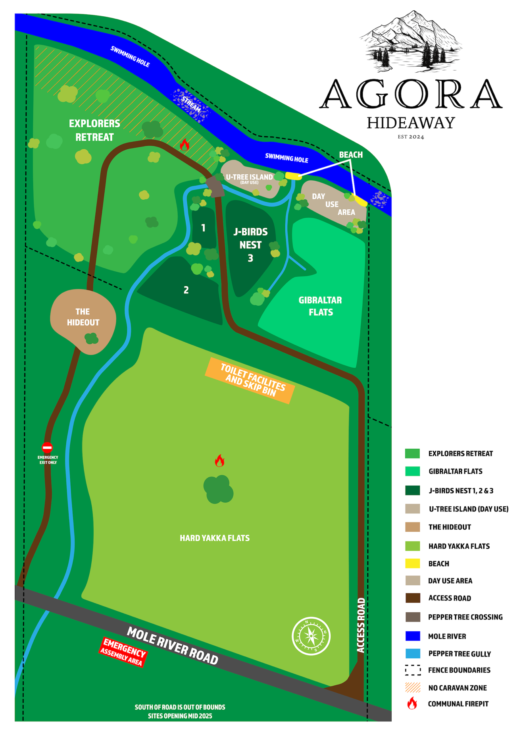

**Imagery**

Photos have been provided to illustrate the temporary event setup in the context of the surrounding environment. These are examples from previous events held by Big Oz Explorers, the sister company to Agora Hideaway at similar campsites across Australia.

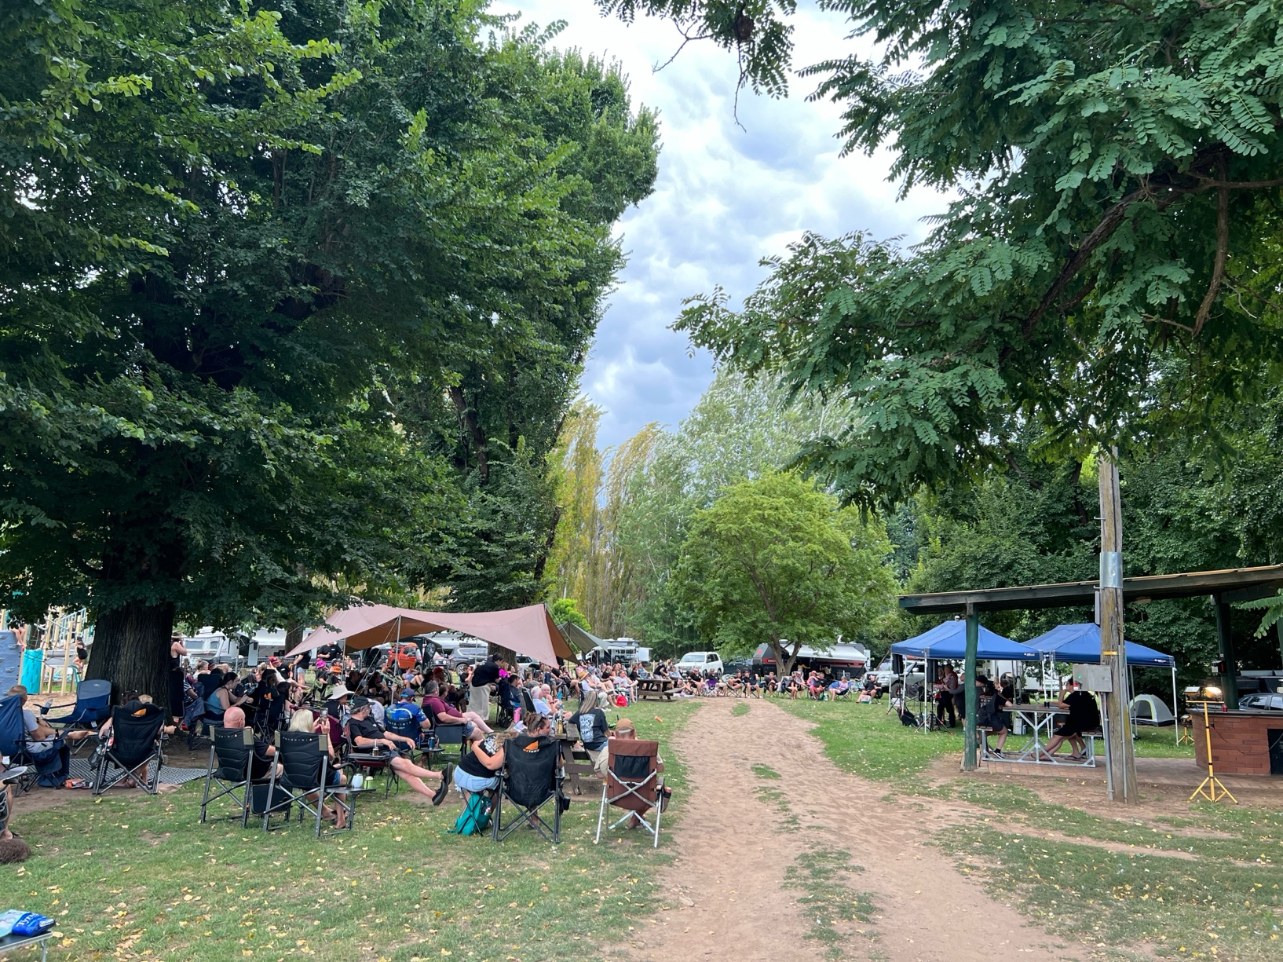

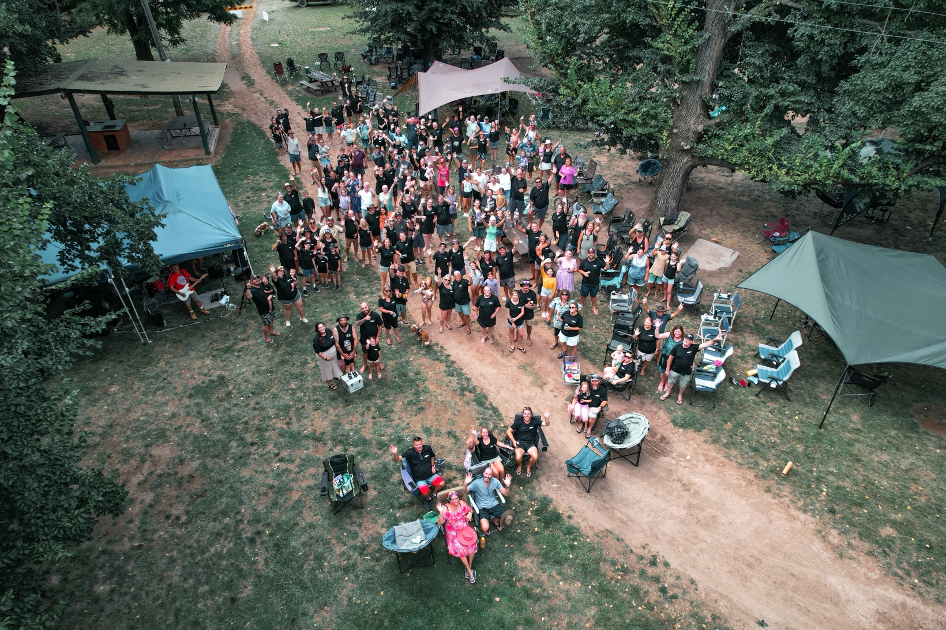

Billy Grace Reserve, Wee Jasper, NSW. 204 people attended this event with 98 caravans.

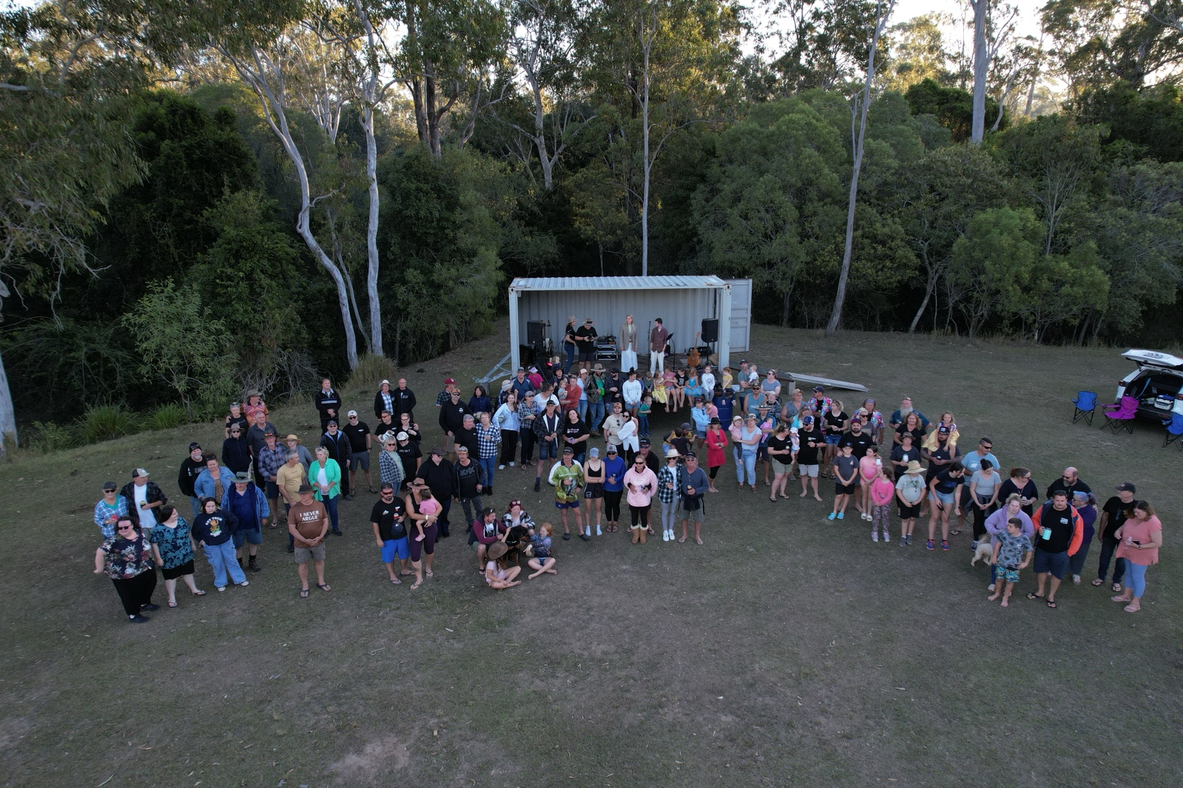

Gootchie Creek Escape, Gootchie, QLD. 163 people attended this event with 64 caravans.

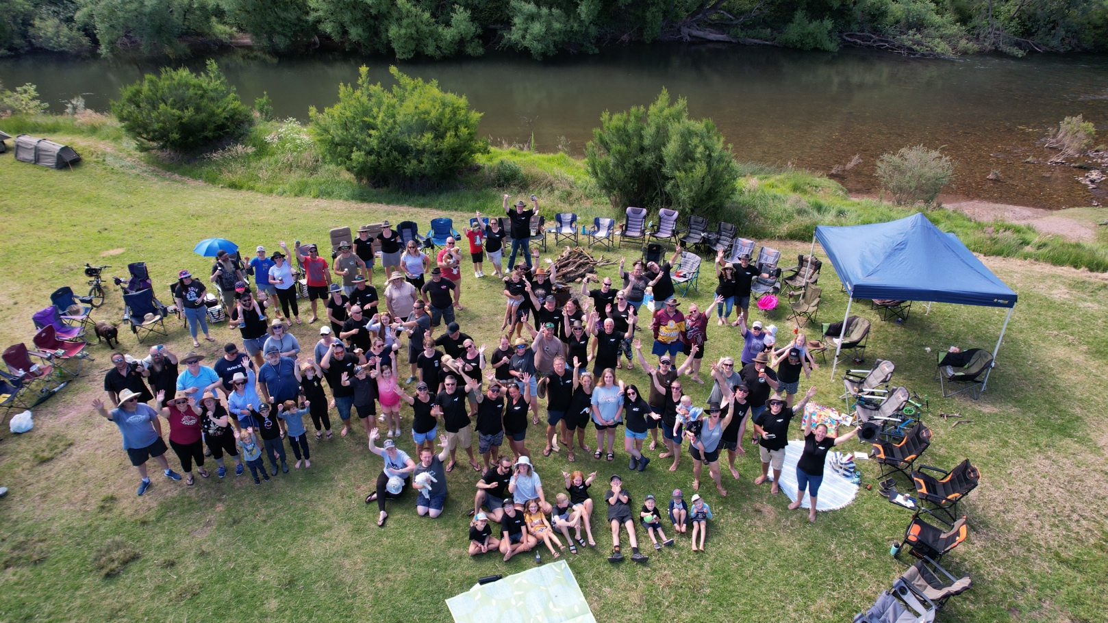

Hidden Valley Campground, VIC. 130 people attanded this event with approximately 60 caravans/campers.

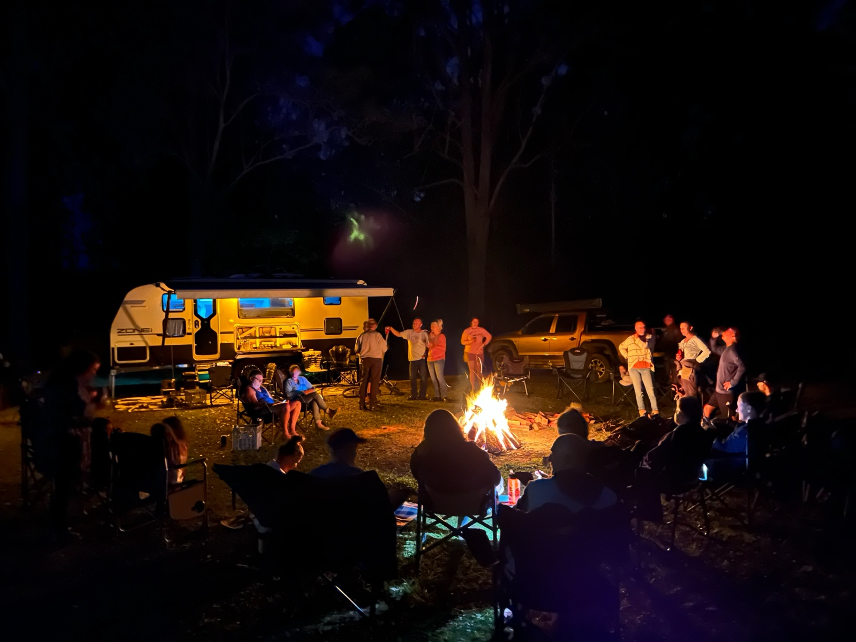

Coffs Harbour Camping, NSW. 88 people attanded this event with approximately 30 caravans.

**Conclusion**

**Summary of Environmental Effects**

The proposed temporary event development approval at Agora Hideaway has been carefully designed to minimise environmental impact. With the mitigation measures outlined in this statement, the development is expected to have a negligible effect on the natural environment.

**Commitment to Compliance**

Agora Hideaway is committed to adhering to all relevant planning policies and environmental guidelines. We will work closely with local authorities to ensure the success of these events while preserving the natural beauty of the area.